**v/b/b/b/Electronics and Robotics 9**

**Project Research: LED Lamp Circuit**

**Name: Sarthak Nadkarni**

[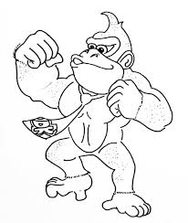](https://www.google.ca/imgres?imgurl=http%3A%2F%2Fwww.drawingskill.com%2Fwp-content%2Fuploads%2F3%2FDonkey-Kong-Drawing-High-Quality.jpg&imgrefurl=http%3A%2F%2Fwww.drawingskill.com%2Fart%2Ftag%2Fdonkey-kong&docid=SMgDJtaEenvmEM&tbnid=VFpcKZqpJUW2nM%3A&vet=10ahUKEwj06Pm0yKblAhUY7J4KHcwpBMAQMwhMKAMwAw..i&w=545&h=645&safe=strict&bih=911&biw=1280&q=images%20of%20donjkey%20kong%20lined%20drawing&ved=0ahUKEwj06Pm0yKblAhUY7J4KHcwpBMAQMwhMKAMwAw&iact=mrc&uact=8)

[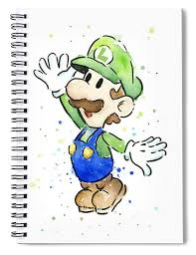](https://www.google.ca/imgres?imgurl=https%3A%2F%2Frender.fineartamerica.com%2Fimages%2Frendered%2Fdefault%2Ffront%2Fspiral-notebook%2Fimages%2Fartworkimages%2Fmedium%2F1%2Fluigi-watercolor-olga-shvartsur.jpg%3F%26targetx%3D-4%26targety%3D0%26imagewidth%3D688%26imageheight%3D961%26modelwidth%3D680%26modelheight%3D961%26backgroundcolor%3DFFFFFF%26orientation%3D0%26producttype%3Dspiralnotebook&imgrefurl=https%3A%2F%2Ffineartamerica.com%2Ffeatured%2Fluigi-watercolor-olga-shvartsur.html%3Fproduct%3Dspiral-notebook&docid=dYwBhdPtYAjG7M&tbnid=kxxfZO6EBM8nMM%3A&vet=10ahUKEwjaibyCyKblAhU2FjQIHVgaBqEQMwhSKAswCw..i&w=770&h=1000&safe=strict&bih=911&biw=1280&q=images%20of%20luigi%20lined%20drawing&ved=0ahUKEwjaibyCyKblAhU2FjQIHVgaBqEQMwhSKAswCw&iact=mrc&uact=8)

[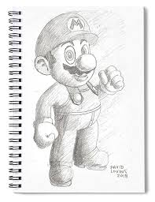](https://www.google.ca/imgres?imgurl=https%3A%2F%2Frender.fineartamerica.com%2Fimages%2Frendered%2Fdefault%2Ffront%2Fspiral-notebook%2Fimages%2Fartworkimages%2Fmedium%2F1%2Fmario-pencil-drawing-david-lovins.jpg%3F%26targetx%3D-31%26targety%3D0%26imagewidth%3D742%26imageheight%3D961%26modelwidth%3D680%26modelheight%3D961%26backgroundcolor%3DB3B1AE%26orientation%3D0%26producttype%3Dspiralnotebook&imgrefurl=https%3A%2F%2Fpixels.com%2Ffeatured%2Fmario-pencil-drawing-david-lovins.html%3Fproduct%3Dspiral-notebook&docid=dEmhqqQtNw1HwM&tbnid=6r-iTexmEvq3bM%3A&vet=10ahUKEwimyv3mx6blAhU_JzQIHTooDX0QMwhUKAgwCA..i&w=770&h=1000&safe=strict&bih=911&biw=1280&q=images%20of%20mario%20lined%20drawing&ved=0ahUKEwimyv3mx6blAhU_JzQIHTooDX0QMwhUKAgwCA&iact=mrc&uact=8)

[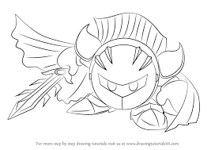](https://www.google.ca/imgres?imgurl=https%3A%2F%2Fwww.drawingtutorials101.com%2Fdrawing-tutorials%2FVideo-Games%2FSuper-Smash-Bros-%2Fmeta-knight%2Fhow-to-draw-Meta-Knight-from-Super-Smash-Bros-step-0.png&imgrefurl=https%3A%2F%2Fwww.drawingtutorials101.com%2Fhow-to-draw-meta-knight-from-super-smash-bros&docid=Pd-fsthAGT5iEM&tbnid=eTSyeDSOgXR_tM%3A&vet=10ahUKEwiZtKGRyablAhXeJzQIHfxTDCMQMwhIKAAwAA..i&w=800&h=566&safe=strict&bih=911&biw=1280&q=images%20of%20meta%20knight%20lined%20drawing&ved=0ahUKEwiZtKGRyablAhXeJzQIHfxTDCMQMwhIKAAwAA&iact=mrc&uact=8)

[](https://www.google.ca/imgres?imgurl=https%3A%2F%2Fcdn.drawception.com%2Fimages%2Fpanels%2F2018%2F4-20%2FyLChpw9pe6-15.png&imgrefurl=https%3A%2F%2Fdrawception.com%2Fgame%2FyLChpw9pe6%2Fkirby%2F&docid=XcZNCEZuTk8Z7M&tbnid=XN-gbydNIdX7KM%3A&vet=10ahUKEwiKmK_9yKblAhUDNH0KHaR6CbAQMwhVKAgwCA..i&w=300&h=250&safe=strict&bih=911&biw=1280&q=images%20of%20kirby%5C%20lined%20drawing&ved=0ahUKEwiKmK_9yKblAhUDNH0KHaR6CbAQMwhVKAgwCA&iact=mrc&uact=8)

[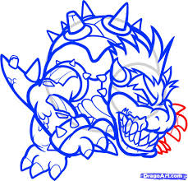](https://www.google.ca/imgres?imgurl=https%3A%2F%2Fimgs.steps.dragoart.com%2Fhow-to-draw-zombie-bowser-zombie-bowser-step-9_1_000000072349_5.jpg&imgrefurl=https%3A%2F%2Fwww.dragoart.com%2Ftuts%2F9545%2F1%2F1%2Fhow-to-draw-zombie-bowser%2C-zombie-bowser.htm&docid=XpJOY7PxJeiH6M&tbnid=cpuJ7iZ05u867M%3A&vet=10ahUKEwjjp_zoyKblAhWFKDQIHZRdAB0QMwhSKAUwBQ..i&w=931&h=891&safe=strict&bih=911&biw=1280&q=images%20of%20bowser%20lined%20drawing&ved=0ahUKEwjjp_zoyKblAhWFKDQIHZRdAB0QMwhSKAUwBQ&iact=mrc&uact=8)

[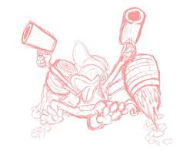](https://www.google.ca/imgres?imgurl=https%3A%2F%2Fpm1.narvii.com%2F6960%2F6d175ce34fa4e5a978fab71c9071b7fcb4c7d34er1-1136-909v2_hq.jpg&imgrefurl=https%3A%2F%2Faminoapps.com%2Fc%2Fsmash%2Fpage%2Fblog%2Fsmash-ultimate-36-diddy-kong%2F2QfN_ujBzXMNM8dDP0Y0rx205zbmk&docid=tN5MV5Ba9e2cPM&tbnid=_3kfPiEveUq5IM%3A&vet=10ahUKEwjh8taxyablAhVIoZ4KHYGBCdAQMwiiAShEMEQ..i&w=1024&h=819&safe=strict&bih=911&biw=1280&q=images%20of%20diddy%20kong%20falcomn%20lined%20drawing&ved=0ahUKEwjh8taxyablAhVIoZ4KHYGBCdAQMwiiAShEMEQ&iact=mrc&uact=8)

[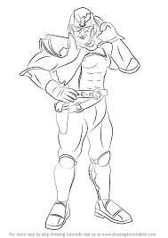](https://www.google.ca/imgres?imgurl=https%3A%2F%2Fwww.drawingtutorials101.com%2Fdrawing-tutorials%2FVideo-Games%2FSuper-Smash-Bros-%2Fcaptain-falcon%2Fhow-to-draw-Captain-Falcon-from-Super-Smash-Bros-step-0.png&imgrefurl=https%3A%2F%2Fwww.drawingtutorials101.com%2Fhow-to-draw-captain-falcon-from-super-smash-bros&docid=-lf1CVTG3tiEQM&tbnid=pjsUIM99_bWB0M%3A&vet=10ahUKEwioqtWfyablAhVgFjQIHXV4DG0QMwhPKAAwAA..i&w=596&h=843&safe=strict&bih=911&biw=1280&q=images%20of%20captainn%20falcomn%20lined%20drawing&ved=0ahUKEwioqtWfyablAhVgFjQIHXV4DG0QMwhPKAAwAA&iact=mrc&uact=8)

[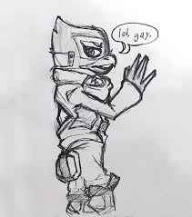](https://www.google.ca/imgres?imgurl=https%3A%2F%2Fscontent-cdt1-1.cdninstagram.com%2Fv%2Ft51.2885-15%2Fsh0.08%2Fe35%2Fp750x750%2F50639566_549223915589555_2213492417953843860_n.jpg%3F_nc_ht%3Dscontent-cdt1-1.cdninstagram.com%26oh%3D2bec73261b0b2d143c28222cdd4a46ff%26oe%3D5DEA9F00%26ig_cache_key%3DMTk3ODYzMTA3OTE3OTAzOTc1NQ%253D%253D.2&imgrefurl=https%3A%2F%2Fmysocialmate.com%2Ftag%2Fdoodlerequests&docid=REfMoScN7BVC_M&tbnid=tnl1pk-o1u9bmM%3A&vet=10ahUKEwiv7L_KyablAhVMoZ4KHTggCckQMwh9KB4wHg..i&w=750&h=850&safe=strict&bih=911&biw=1280&q=images%20of%20falco%20lined%20drawing&ved=0ahUKEwiv7L_KyablAhVMoZ4KHTggCckQMwh9KB4wHg&iact=mrc&uact=8)

**Electronics and Robotics 9**

**Project Research: LED Lamp Circuit**

**Name: Sarthak Nadkarni**

[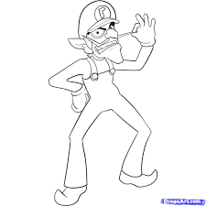](https://www.google.ca/imgres?imgurl=https%3A%2F%2Fimgs.steps.dragoart.com%2Fhow-to-draw-waluigi-step-6_1_000000032731_5.jpg&imgrefurl=https%3A%2F%2Fwww.dragoart.com%2Ftuts%2F5873%2F2%2F1%2F32731%2Fhow-to-draw-waluigi-step-6.htm&docid=Z-jxvwtnoHw8TM&tbnid=xj68AXHQfL12UM%3A&vet=10ahUKEwiw79z2yablAhVWnJ4KHXl8CEkQMwhSKAQwBA..i&w=1076&h=1076&safe=strict&bih=911&biw=1280&q=images%20of%20waluigi%20lined%20drawing&ved=0ahUKEwiw79z2yablAhVWnJ4KHXl8CEkQMwhSKAQwBA&iact=mrc&uact=8)

[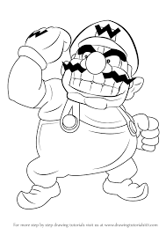](https://www.google.ca/imgres?imgurl=https%3A%2F%2Fwww.drawingtutorials101.com%2Fdrawing-tutorials%2FVideo-Games%2FSuper-Mario%2Fwario%2Fhow-to-draw-Wario-from-Super-Mario-step-0.png&imgrefurl=https%3A%2F%2Fwww.drawingtutorials101.com%2Fhow-to-draw-wario-from-super-mario&docid=s-5I0p53gk7mBM&tbnid=T6m8tv-rKh4nqM%3A&vet=10ahUKEwjVxviKyqblAhXRtp4KHXXGCdsQMwhOKAAwAA..i&w=598&h=844&safe=strict&bih=911&biw=1280&q=images%20of%20wario%20lined%20drawing&ved=0ahUKEwjVxviKyqblAhXRtp4KHXXGCdsQMwhOKAAwAA&iact=mrc&uact=8)

[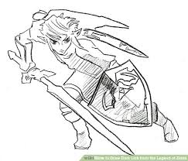](https://www.google.ca/imgres?imgurl=https%3A%2F%2Fwww.wikihow.com%2Fimages%2Fthumb%2F4%2F4d%2FDraw-Dark-Link-from-the-Legend-of-Zelda-Step-7.jpg%2Faid1893339-v4-654px-Draw-Dark-Link-from-the-Legend-of-Zelda-Step-7.jpg&imgrefurl=https%3A%2F%2Fwww.wikihow.com%2FDraw-Dark-Link-from-the-Legend-of-Zelda&docid=54BLaZur_zvJeM&tbnid=Y9iVhP-lep1yZM%3A&vet=10ahUKEwjJisTkyablAhWYnp4KHR_PBjAQMwhuKAkwCQ..i&w=654&h=560&safe=strict&bih=911&biw=1280&q=images%20of%20zelda%20lined%20drawing&ved=0ahUKEwjJisTkyablAhWYnp4KHR_PBjAQMwhuKAkwCQ&iact=mrc&uact=8)

[](https://www.google.ca/imgres?imgurl=https%3A%2F%2Fi.pinimg.com%2Foriginals%2Fe7%2F1c%2Fe5%2Fe71ce575752242ef54f8fbe804c375ea.jpg&imgrefurl=https%3A%2F%2Fwww.pinterest.com%2Fpin%2F134826582577515913%2F&docid=gersAVa7E5spyM&tbnid=E5fuG6UlGRpAsM%3A&vet=10ahUKEwjaibyCyKblAhU2FjQIHVgaBqEQMwhOKAcwBw..i&w=670&h=867&safe=strict&bih=911&biw=1280&q=images%20of%20luigi%20lined%20drawing&ved=0ahUKEwjaibyCyKblAhU2FjQIHVgaBqEQMwhOKAcwBw&iact=mrc&uact=8)

[](https://www.google.ca/imgres?imgurl=https%3A%2F%2Fi.pinimg.com%2F236x%2F5f%2Fd6%2F7c%2F5fd67c43fb4f73dd3d3326b06a5e177f--kids-colouring-coloring-pages-for-kids.jpg&imgrefurl=https%3A%2F%2Fwww.pinterest.com%2Fartsan2p%2Fsponge-bob-theme%2F&docid=QFfXKW8JV9auoM&tbnid=2mt5S2c8Mib3OM%3A&vet=10ahUKEwjv7ri7yqblAhVYop4KHYeGBwIQMwhRKAEwAQ..i&w=235&h=267&safe=strict&bih=911&biw=1280&q=images%20of%20spongebob%5C%20lined%20drawing&ved=0ahUKEwjv7ri7yqblAhVYop4KHYeGBwIQMwhRKAEwAQ&iact=mrc&uact=8)

[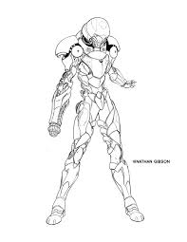](https://www.google.ca/imgres?imgurl=https%3A%2F%2Fi.pinimg.com%2Foriginals%2Fa4%2F3d%2Fbd%2Fa43dbd37c105503bbe56671e6df2d3a3.jpg&imgrefurl=https%3A%2F%2Fwww.pinterest.com%2Fpin%2F546342998520284090%2F&docid=QUGS-2VkLmaZuM&tbnid=PFzlP67NqivchM%3A&vet=10ahUKEwjLr7CpyqblAhWG_J4KHY8ZBmkQMwhAKAIwAg..i&w=612&h=792&safe=strict&bih=911&biw=1280&q=images%20of%20samus%20lined%20drawing&ved=0ahUKEwjLr7CpyqblAhWG_J4KHY8ZBmkQMwhAKAIwAg&iact=mrc&uact=8)

[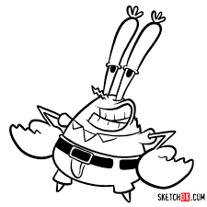](https://www.google.ca/imgres?imgurl=https%3A%2F%2Fsketchok.com%2Fimages%2Farticles%2F01-cartoons%2F041-spongebob%2F09%2F09.jpg&imgrefurl=https%3A%2F%2Fsketchok.com%2Fcartoon-characters%2Fspongebob%2Fhow-to-draw-mr-krabs-spongebob&docid=3_iXbLCo6bEQjM&tbnid=IxEczfSSxsEMjM%3A&vet=10ahUKEwjEqLTIyqblAhUTv54KHb7aDCMQMwhIKAAwAA..i&w=1200&h=1200&safe=strict&bih=911&biw=1280&q=images%20of%20mr.krabs%20lined%20drawing&ved=0ahUKEwjEqLTIyqblAhUTv54KHb7aDCMQMwhIKAAwAA&iact=mrc&uact=8)

[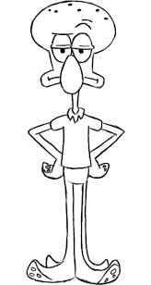](https://www.google.ca/imgres?imgurl=https%3A%2F%2Fi.pinimg.com%2Foriginals%2F59%2F64%2F0c%2F59640c4dd6bafa392172e85a365a09fb.jpg&imgrefurl=https%3A%2F%2Fwww.pinterest.com%2Fpin%2F182606959862339809%2F&docid=W3sh0Vd-Vpd6QM&tbnid=VXTsorRTHQoRjM%3A&vet=10ahUKEwiGr-LYyqblAhXVsJ4KHewDBzAQMwhJKAAwAA..i&w=298&h=560&safe=strict&bih=911&biw=1280&q=images%20of%20squidwards%20lined%20drawing&ved=0ahUKEwiGr-LYyqblAhXVsJ4KHewDBzAQMwhJKAAwAA&iact=mrc&uact=8)

[](https://www.google.ca/imgres?imgurl=https%3A%2F%2Fimgs.steps.dragoart.com%2Fhow-to-draw-patrick-star-step-5_1_000000002781_5.jpg&imgrefurl=https%3A%2F%2Fwww.dragoart.com%2Ftuts%2F571%2F1%2F1%2Fhow-to-draw-patrick-star-from-spongebob-squarepants.htm&docid=dG-yoAjbXaySuM&tbnid=nET_2lNGzET9nM%3A&vet=10ahUKEwjpsKfryqblAhXJpJ4KHZ9XAEoQMwhNKAAwAA..i&w=557&h=817&safe=strict&bih=911&biw=1280&q=images%20of%20patrick%20star%20lined%20drawing&ved=0ahUKEwjpsKfryqblAhXJpJ4KHZ9XAEoQMwhNKAAwAA&iact=mrc&uact=8)

**Electronics and Robotics 9**

**Project Research: LED Lamp Circuit**

**Name: Sarthak Nadkarni**

[](https://www.google.ca/imgres?imgurl=https%3A%2F%2Fi7.pngguru.com%2Fpreview%2F335%2F872%2F919%2Fplaystation-4-playstation-3-sony-logo-ps4.jpg&imgrefurl=https%3A%2F%2Fwww.pngguru.com%2Fsearch%3Fpng%3Dplaystation&docid=QLkRnodjuLpv_M&tbnid=GImsB-yG5GO9aM%3A&vet=10ahUKEwiBhYGAy6blAhUOr54KHSrmA14QMwheKBIwEg..i&w=800&h=800&safe=strict&bih=911&biw=1280&q=images%20of%20play%20station%204%20logo%20lined%20drawing&ved=0ahUKEwiBhYGAy6blAhUOr54KHSrmA14QMwheKBIwEg&iact=mrc&uact=8)

[](https://www.google.ca/imgres?imgurl=https%3A%2F%2Fpokemonletsgo.pokemon.com%2Fassets%2Fimg%2Fcommon%2Fchar-pikachu.png&imgrefurl=http%3A%2F%2Fpokemonletsgo.pokemon.com%2Fen-us%2F&docid=3VG55eRnrC4t_M&tbnid=a4W8WlsxNgW76M%3A&vet=10ahUKEwjpjuu20KblAhXSPH0KHRO3DjAQMwh7KAEwAQ..i&w=478&h=606&safe=strict&bih=911&biw=1280&q=images%20of%20a%20pickachu&ved=0ahUKEwjpjuu20KblAhXSPH0KHRO3DjAQMwh7KAEwAQ&iact=mrc&uact=8)

[](https://www.google.ca/imgres?imgurl=https%3A%2F%2Fwww.ssbwiki.com%2Fimages%2Fthumb%2F5%2F5e%2FBowser_Jr._artwork.png%2F320px-Bowser_Jr._artwork.png&imgrefurl=https%3A%2F%2Fwww.ssbwiki.com%2FBowser_Jr.&docid=dVMSm0ke8Sje_M&tbnid=PYCQeBdlvtoFRM%3A&vet=10ahUKEwjl1Jitx6blAhV0MX0KHU89AsIQMwhvKBswGw..i&w=320&h=388&safe=strict&bih=911&biw=1280&q=images%20of%20peach%20from%20bowser%20junior&ved=0ahUKEwjl1Jitx6blAhV0MX0KHU89AsIQMwhvKBswGw&iact=mrc&uact=8)

[](https://www.google.ca/imgres?imgurl=http%3A%2F%2Fclipartmag.com%2Fimages%2Fmario-coloring-pages-10.jpg&imgrefurl=http%3A%2F%2Fclipartmag.com%2Ftag%2Fmario%2520kart&docid=Viejgaqwv53hiM&tbnid=G_iKpalLQkh7XM%3A&vet=10ahUKEwiC7bnUy6blAhVWo54KHchPAaMQMwieAShAMEA..i&w=1139&h=1719&safe=strict&bih=911&biw=1280&q=images%20of%20toad%20from%20mario%20party%20dslogo%20lined%20drawing&ved=0ahUKEwiC7bnUy6blAhVWo54KHchPAaMQMwieAShAMEA&iact=mrc&uact=8)

[](https://www.google.ca/imgres?imgurl=http%3A%2F%2Fwww.cartonionline.com%2Fen%2Fcoloring_page%2Fteen_titans_go%2Fgizmo.jpg&imgrefurl=http%3A%2F%2Fwww.cartonionline.com%2Fen%2Fcoloring_page%2Fteen_titans_go%2Fgizmo.htm&docid=dGDbgBLqvd0B1M&tbnid=GTSXpLtJpXqRoM%3A&vet=10ahUKEwik_r-riK7lAhUwITQIHQgfCAMQMwhPKAQwBA..i&w=1054&h=992&safe=strict&bih=911&biw=1280&q=images%20of%20gizmo%20go%20line%20drawing&ved=0ahUKEwik_r-riK7lAhUwITQIHQgfCAMQMwhPKAQwBA&iact=mrc&uact=8)

[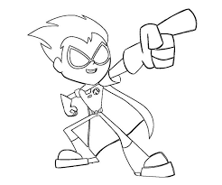](https://www.google.ca/imgres?imgurl=https%3A%2F%2Fi.pinimg.com%2Foriginals%2F62%2F52%2F67%2F625267c68aef9e53458e5fdd2760ed1c.jpg&imgrefurl=https%3A%2F%2Fwww.pinterest.com%2Fpin%2F135108057552232546%2F&docid=dpqGv2ACN96m-M&tbnid=Md73M5DMJntxWM%3A&vet=10ahUKEwj_xcWrh67lAhXMl54KHYXVCpkQMwg6KAMwAw..i&w=736&h=613&safe=strict&bih=911&biw=1280&q=images%20of%20robin%20from%20teen%20titans%20go%20line%20drawing&ved=0ahUKEwj_xcWrh67lAhXMl54KHYXVCpkQMwg6KAMwAw&iact=mrc&uact=8)

[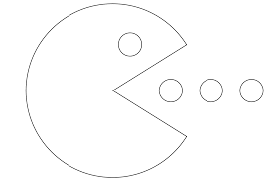](https://www.google.ca/imgres?imgurl=https%3A%2F%2Fi.pinimg.com%2Foriginals%2F2d%2F25%2F49%2F2d25496d2f74a30074d80c1e60062bcc.png&imgrefurl=https%3A%2F%2Fwww.pinterest.com%2Fpin%2F188306828150581903%2F&docid=mxLVZltjiCmcPM&tbnid=peNMHxgHgKVwXM%3A&vet=10ahUKEwiihrGozablAhVcIjQIHc9bDzoQMwhUKAQwBA..i&w=1979&h=1290&safe=strict&bih=911&biw=1280&q=images%20of%20pac%20man%5D%20logolined%20drawing&ved=0ahUKEwiihrGozablAhVcIjQIHc9bDzoQMwhUKAQwBA&iact=mrc&uact=8)

[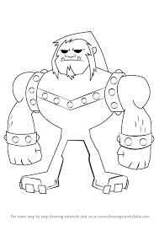](https://www.google.ca/imgres?imgurl=https%3A%2F%2Fwww.drawingtutorials101.com%2Fdrawing-tutorials%2FCartoon-TV%2FTeen-Titans-Go%2Fmammoth%2Fhow-to-draw-Mammoth-from-Teen-Titans-Go-step-0.png&imgrefurl=https%3A%2F%2Fwww.drawingtutorials101.com%2Fhow-to-draw-mammoth-from-teen-titans-go&docid=8kNa2ixbECeV5M&tbnid=KYxwC6ID5SsfrM%3A&vet=10ahUKEwiEur24iK7lAhVUOH0KHcBdBM0QMwhPKAEwAQ..i&w=598&h=844&safe=strict&bih=911&biw=1280&q=images%20of%20mammoth%20go%20line%20drawing&ved=0ahUKEwiEur24iK7lAhVUOH0KHcBdBM0QMwhPKAEwAQ&iact=mrc&uact=8)

[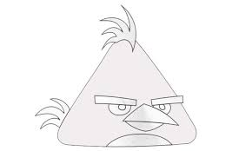](https://www.google.ca/imgres?imgurl=https%3A%2F%2Fmy-how-to-draw.com%2Fwp-content%2Fuploads%2F2017%2F09%2FHow-to-draw-Angry-Birds-Chuck-800x480.jpg&imgrefurl=https%3A%2F%2Fmy-how-to-draw.com%2Fhow-to-draw-angry-birds-chuck.html&docid=G_mLANy81v6buM&tbnid=r85FuHe76qJ2bM%3A&vet=10ahUKEwitidHPiK7lAhXrHzQIHZW_DPsQMwhTKAIwAg..i&w=800&h=480&safe=strict&bih=911&biw=1280&q=images%20of%20chuck%20go%20line%20drawing&ved=0ahUKEwitidHPiK7lAhXrHzQIHZW_DPsQMwhTKAIwAg&iact=mrc&uact=8)

**Electronics and Robotics 9**

**Project Research: LED Lamp Circuit**

**Name: Sarthak Nadkarni**

[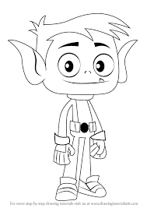](https://www.google.ca/imgres?imgurl=https%3A%2F%2Fi.pinimg.com%2Foriginals%2Fa8%2F53%2F23%2Fa85323f45084e2fe899197f162a0f2d9.png&imgrefurl=https%3A%2F%2Fwww.pinterest.com%2Fpin%2F737464507704071044%2F&docid=2HgosDf-TsOI9M&tbnid=YY3b6SESI4i5_M%3A&vet=10ahUKEwiWsrukzqblAhWwIjQIHc9PD9QQMwg6KAAwAA..i&w=598&h=844&safe=strict&bih=911&biw=1280&q=images%20of%20teen%20titans%20logolined%20drawing&ved=0ahUKEwiWsrukzqblAhWwIjQIHc9PD9QQMwg6KAAwAA&iact=mrc&uact=8)

[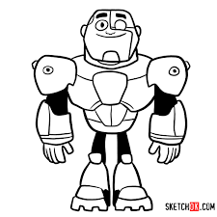](https://www.google.ca/imgres?imgurl=https%3A%2F%2Fsketchok.com%2Fimages%2Farticles%2F01-cartoons%2F053-teen-titans%2F05%2F11.jpg&imgrefurl=https%3A%2F%2Fsketchok.com%2Fcartoon-characters%2Fteen-titans%2Fhow-to-draw-cyborg-chibi-teen-titans&docid=2vK3htBfwP581M&tbnid=-o-rP4F2xk8XiM%3A&vet=10ahUKEwiWsrukzqblAhWwIjQIHc9PD9QQMwg-KAQwBA..i&w=1200&h=1200&safe=strict&bih=911&biw=1280&q=images%20of%20teen%20titans%20logolined%20drawing&ved=0ahUKEwiWsrukzqblAhWwIjQIHc9PD9QQMwg-KAQwBA&iact=mrc&uact=8)

[](https://www.google.ca/imgres?imgurl=https%3A%2F%2Fmdm.scene7.com%2Fis%2Fimage%2FMDM%2F2018-fifa-world-cup-commemorative-coin-logo_obverse%3F%24mf_Produktbild%24%26%24muenze_1%3D2018-fifa-world-cup-commemorative-coin-logo_france%26%24muenze_2%3D2018-fifa-world-cup-commemorative-coin-logo_obverse%26%24wa_10%3Dlaola-fifa2018-wave-silver-coinbar-bnt-coins_obverse-reverse&imgrefurl=https%3A%2F%2Fwww.bnt.org.uk%2F2018-fifa-world-cup-russiatm-france&docid=dPUmTEUEtjCgjM&tbnid=QjFgkE9C1fy5HM%3A&vet=10ahUKEwjfrbb1zablAhUPJTQIHeaYAhgQMwh3KBgwGA..i&w=535&h=420&safe=strict&bih=911&biw=1280&q=images%20of%20fifa%20logolined%20drawing&ved=0ahUKEwjfrbb1zablAhUPJTQIHeaYAhgQMwh3KBgwGA&iact=mrc&uact=8)

[](https://www.google.ca/imgres?imgurl=https%3A%2F%2Fpreviews.123rf.com%2Fimages%2Fjomaplaon%2Fjomaplaon1206%2Fjomaplaon120600034%2F14117173-illustration-of-a-basketball-outline-isolated-in-white-background.jpg&imgrefurl=https%3A%2F%2Fwww.123rf.com%2Fphoto_14117173_illustration-of-a-basketball-outline-isolated-in-white-background.html&docid=4on35EEo7wq6TM&tbnid=aqLjvHVkn0xiNM%3A&vet=10ahUKEwjhvO_Oz6blAhULj54KHebuBKYQMwhwKAcwBw..i&w=1300&h=1300&safe=strict&bih=911&biw=1280&q=images%20of%20a%20basketball&ved=0ahUKEwjhvO_Oz6blAhULj54KHebuBKYQMwhwKAcwBw&iact=mrc&uact=8)

[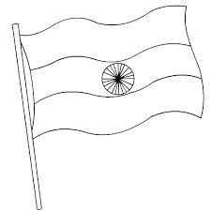](https://www.google.ca/imgres?imgurl=https%3A%2F%2Fi.pinimg.com%2Foriginals%2F65%2F27%2F64%2F652764593eb5f8d99870601a663c2269.gif&imgrefurl=https%3A%2F%2Fwww.pinterest.com%2Fpin%2F550142910729487393%2F&docid=RQkJFQ47KgVpIM&tbnid=wMCpNP1xua4sKM%3A&vet=10ahUKEwj8rIStz6blAhWKtZ4KHTDdBR4QMwhKKAEwAQ..i&w=500&h=500&safe=strict&bih=911&biw=1280&q=images%20of%20india%20flag%20lined%20drawing&ved=0ahUKEwj8rIStz6blAhWKtZ4KHTDdBR4QMwhKKAEwAQ&iact=mrc&uact=8)

[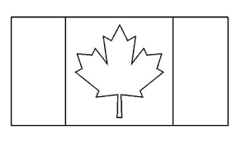](https://www.google.ca/imgres?imgurl=https%3A%2F%2Fi.pinimg.com%2Foriginals%2F39%2F86%2Fa6%2F3986a6913e480920e77bb34746d782a8.jpg&imgrefurl=https%3A%2F%2Fwww.pinterest.com%2Fpin%2F11610911523524801%2F&docid=u34sCvpV8AGcIM&tbnid=6n48j4QE4BGz5M%3A&vet=10ahUKEwja7fHVzqblAhVVIDQIHZ3eBBkQMwhRKAAwAA..i&w=444&h=271&safe=strict&bih=911&biw=1280&q=images%20of%20canadian%20flag%20logolined%20drawing&ved=0ahUKEwja7fHVzqblAhVVIDQIHZ3eBBkQMwhRKAAwAA&iact=mrc&uact=8)

[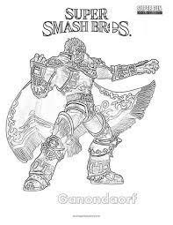](https://www.google.ca/imgres?imgurl=https%3A%2F%2Fwww.superfuncoloring.com%2Fwp-content%2Fuploads%2F2018%2F06%2F14-Ganondorf-Super-Smash-Bros-Coloring-Pages.jpg&imgrefurl=https%3A%2F%2Fwww.superfuncoloring.com%2Fcoloring%2Fganondorf-super-smash-brothers-coloring-page%2F&docid=-aGydyXhyYGmtM&tbnid=mZ1th28rzm9UXM%3A&vet=10ahUKEwis5cePia7lAhXHIDQIHdxUBEcQMwhPKAAwAA..i&w=464&h=600&safe=strict&bih=911&biw=1280&q=images%20of%20gandendorf%20from%20super%20smash%20bros%20go%20line%20drawing&ved=0ahUKEwis5cePia7lAhXHIDQIHdxUBEcQMwhPKAAwAA&iact=mrc&uact=8)

[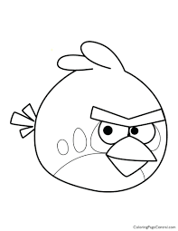](https://www.google.ca/imgres?imgurl=http%3A%2F%2Ffindpage.co%2Fwp-content%2Fuploads%2F2019%2F04%2Fangry-birds-red-coloring.jpg&imgrefurl=http%3A%2F%2Ffindpage.co%2Fangry-birds-drawing-for-coloring%2F&docid=UaazM11yNzmJ3M&tbnid=LUoV30ru5AOXeM%3A&vet=10ahUKEwipkIbmiK7lAhUcITQIHa8rAIAQMwhHKAIwAg..i&w=850&h=1100&safe=strict&bih=911&biw=1280&q=images%20of%20red%20from%20angry%20birds%20%20go%20line%20drawing&ved=0ahUKEwipkIbmiK7lAhUcITQIHa8rAIAQMwhHKAIwAg&iact=mrc&uact=8)

[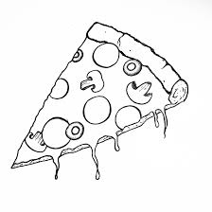](https://www.google.ca/imgres?imgurl=https%3A%2F%2Fi.pinimg.com%2Foriginals%2Fb2%2Fc9%2F32%2Fb2c932201b28abfac91617438325f9cb.jpg&imgrefurl=https%3A%2F%2Fwww.pinterest.com%2Fpin%2F543598617515893499%2F&docid=DfnDbcybV4FUjM&tbnid=RhtLa6YbkJc6_M%3A&vet=10ahUKEwjproG4ia7lAhXqFTQIHfUcDxcQMwhMKAIwAg..i&w=2852&h=2852&itg=1&safe=strict&bih=911&biw=1280&q=images%20of%20pizza%20%20go%20line%20drawing&ved=0ahUKEwjproG4ia7lAhXqFTQIHfUcDxcQMwhMKAIwAg&iact=mrc&uact=8)